Fast**National University of Computer & Emerging Sciences, Karachi  
Fall/Spring/Summer-2020 CS-Department  
Final Examination   
25th June, 2020; 9:00 to 12:00 pm**

|  |  |  |
| --- | --- | --- |
| **Course Code: SS108** | **Course Name: Technical & Business Writing** | |
| **Instructor Name: Ms. Sameera Sultan & Ms. Javeria Ali** | | |
| **Student Roll No:** | | **Section No:** |

**Instructions:**

* **Read each question carefully before answering it.**
* **Answer all the questions in your answer copy.**
* **Write neatly.**
* **Use a black or any dark colored pen.**

**Time: 3 hours** **Max Marks**: **80** **points**

**Q1**

1. **Reduce wordiness in the following sentences using different techniques taught in the course. [5]**
2. The movie was outstanding for several reasons. One reason why it was outstanding is because everything like the music and the plot had a meaning and a place.
3. It seems that juvenile delinquency among children and teenagers is expanding and growing at an ever-increasing rate in this modern day and age of the twenty-first century.
4. The guerillas kidnapped the hostage at gun point by holding a gun to his head. The next thing they did was to put a blindfold around his eyes. Then they put handcuffs on his wrists and forced him into a car.
5. Women who have jobs and also keep house have many problems. These women have little time for recreation. Often these women don’t get enough sleep.
6. The theater has three main technical areas. These areas are costumes, scenery, and lighting.
7. **The following is an extract from a technical report on the use of internet during the lockdown imposed due to COVID 19. Read the extract and revise it for precision and clarity as it contains vague and impressionistic information. [10]**

Due to COVID 19, a nationwide lockdown has been imposed in most of the countries around the globe. This has led to an unusual increase in the use of the internet. An average internet user is using the internet a lot more than his/her pre-COVID 19 usage. There are many reasons for this increase in the in the use of internet. A great majority of the industries, business, and organizations have adopted the work from home policy due to which internet use has increased to an unprecedented degree. Many employees are working from home through the internet. Due to the lockdown, people are confined in their homes and there is not much that can be done for entertainment. Thus, a huge majority of young people have started using internet much more than they used to do before the lockdown. Many online movie streaming websites have seen a record high in their customer base and overall traffic.

1. **The question has two parts:**

**1. Which of the following error message pages employs a politer, apologetic tone with excessive consideration for the user? Give reasons for your answer. You can cite examples from the pages. [2]To change the size of your imported graphic do the following:**

* 1. Select the entire graphic by clicking just above the top of the drawing.
  2. Select **Object**... under **Format** on the main menu.
  3. Choose the **Size** option.
  4. Type in the dimensions you want the graphic to be.
  5. Click OK.

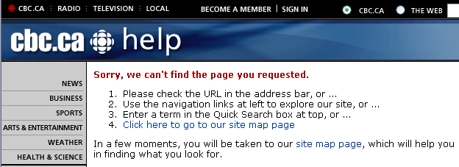

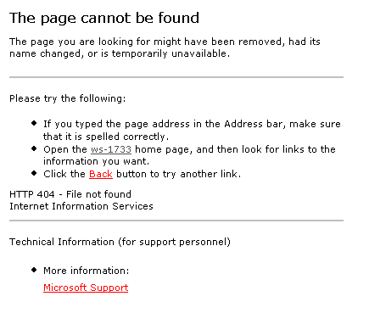

**2. Based on the above samples and using your creativity, construct an error page having a regretful, respectful, considerate, and polite tone and attitude. [5]**

**Q2**

1. **What to include? What to leave out? [5]**

Table 1 contains a collection of details about a research project you have just completed on thunderstorms. Imagine that you're writing documents for each of the 5 following audiences:

**A. Your boss**

**B. Scientists**

**C. The general public**

**D. Politician**

What information about thunderstorms might each ask you for? As you go down the list, write in the blank spaces in front of each detail the letter that correspond to the audiences that you think would find this detail most relevant.

**Table 1. Details About Your Research Project On Thunderstorms**

|  |  |
| --- | --- |
|  | 1. The damage caused by thunderstorms in your country each year. |
|  | 1. A literature review of previous research on thunderstorms. |
|  | 1. Some basic physics of how thunderstorms work. |
|  | 1. How much your project costs. |
|  | 1. A list of everyone who worked on the project. |
|  | 1. Specifications of a new instrument to measure hail size. |
|  | 1. A new result showing a connection between lightning intensity and total rainfall. |
|  | 1. Advice on how protect oneself during thunderstorm. |
|  | 1. Procedures you used to avoid statistical biases in your data. |
|  | 1. Your recommendations for future research. |

**NOTE: Just write the answers in your answer copy. Do not make the table.**

1. **Arrange the information below into the correct order that would be appropriate for a title page: [4]**

A) 27 May 2006  
B) Submitted to City of Wolverhampton College  
C) Prepared by Manjit Sandhu  
D) Report on Sporting Activities Available in Wolverhampton

**Q3**

**Imagine that your group was required to develop a software program as a mandatory part of a course. Your group developed an Airline Reservation System. This system is a complete application for airline reservation programmed in VB.net. Airline Reservation System can inform clients regarding all flights, their arrival, their departure, and seat availability. Through this system, the clients can book, cancel, and print tickets according to the scheduled flights.**

**Write the Introduction section for this Project. You are required to write the following sections only.**

1. **Motivation (150 to 200 words; follow the format taught)**
2. **Project Definition (1 to 2 sentences; follow the correct format)**

**NOTE: Brainstorm to get ideas and make an outline to organize your thoughts. Do not use the internet. You can invent details and use imaginary citations. [10+3]**

**Q4**

**Read the following abstracts and answer the questions that follow: [10]**

**Abstract 1**

This report summarizes what the computing research community knows about the role of trustworthy software for safety and effectiveness of medical devices. Research shows that problems in medical device software result largely from a failure to apply well-known systems engineering techniques, especially during specification of requirements and analysis of human factors. Recommendations to increase the trustworthiness of medical device software include (1) regulatory policies that specify outcome measures rather than technology, (2) collection of statistics on the role of software in medical devices, (3) establishment of open-research platforms for innovation, (4) clearer roles and responsibility for the shared burden of software, (5) clarification of the meaning of substantial equivalence for software, and (6) an increase in FDA’s access to outside experts in software. This report draws upon material from research in software engineering and trustworthy computing, public FDA data, and accident reports to provide a high-level understanding of the issues surrounding the risks and benefits of medical device software.

**Abstract 2**

In the past, Wall Street used to be the center for most of the Stock Exchange and Brokerage firms due to the limitations of communications technology. Today, with the advancement in ICT, investors can use revolutionary Internet Client–server technology to trade stocks nearly anywhere, anytime, independent of brokers’ fee and service limitations. This Project JTrade is a stock market trading program in Java that supports portfolio management, charting, technical analysis, paper trading, and experimental methods like genetic programming. It has features such as equation storing, quotes storing, graphical analysis of stock, maintaining portfolios, paper trading, etc.

The application provides public low–cost transactions and cutting–edge, real–time market information that formerly belonged only to brokers. It has opened up extraordinary new investment opportunities as well as a crucial need for state–of–the–art information.

**Questions:**

1. **State the research problem of Abstract 2 in your own words.**
2. **According to Abstract 1, how many sources are used to collect data to understand the pros and cons of medical device software?**
3. **What is the motivation/justification offered by Abstract 2 for developing JTrade? Explain in your own words.**
4. **State any two recommendations presented by Abstract 1.**
5. **Describe the functionalities of JTrade.**

**Q5**

**Read the following Internship ad and complete the tasks that follow:**

|  |
| --- |
| Obhost is looking for an android developer intern who should possess  • Proper understanding of software design patterns and practice  • Knowledge of Android mobile platform  • Ensuring the best performance and user experience of the application  • Developing new features and user interfaces from wire frame models  • Writing clean, readable, and testable code  Candidates majoring in Software Engineering or Computer Science are strongly encouraged to apply. |

**Tasks:**

1. **Write the Technical Skills section for this ad. [3]**
2. **Write the Projects section for this ad (two projects will be enough) [4]**

**NOTE: You do not have to write any other section of the Resume.**

**Q6**

**Read the following situations for indirect letters and write buffer paragraph (only) for each. You are allowed to assume necessary details to be included in buffer paragraphs. [2+2]**

1. Sue Wang must refuse the request of some staff engineers. They want to copy for home use the latest version of Adobe Photoshop, an expensive licensed software program that her department just received.
2. As a vice president of a real estate brokerage, you serve many clients, and they sometimes ask your company to contribute to their favorite charities. You recently received a letter from Olivia Hernandez asking for a substantial contribution to the National Court Appointed Special Advocate (CASA) Association. On visits to your office, she has told you about its programs to recruit, train, and support volunteers in their work with abused children. She herself is active in your town as a CASA volunteer, helping neglected children find safe, permanent homes. She told you that children with CASA volunteers are more likely to be adopted and are less likely to reenter the child welfare system. You have a soft spot in your heart for children and especially for those who are mistreated. You sincerely want to support CASA and its good work. But times are tough, and you can’t be as generous as you have been in the past. Ms. Hernandez wrote a special letter to you asking you to become a Key contributor, with a pledge of $1,000.

**Q7**

**Write the Introduction and Proposed Solution section (containing all items discussed in the lecture) for the following business proposal topic. [10+5]**

* **Introduction (word limit 150-200)**
* **Proposed Solution (word limit 100-200)**

You work for a web design company, Tex-metrics. Now read the following information.

1. **SEOULITE** is a famous clothing brand of South Korea that has been established in 1900’s.
2. It produces all the trendy clothing for every generation.
3. It has limited branches.
4. It needs to have an e-store.

**-----------------------------------------The End-------------------------------------------------------**